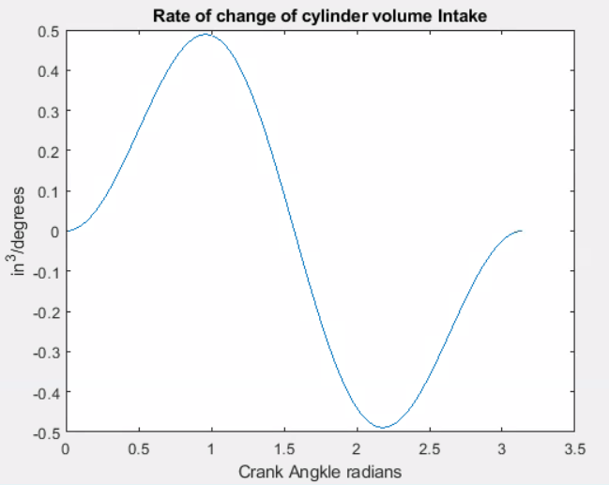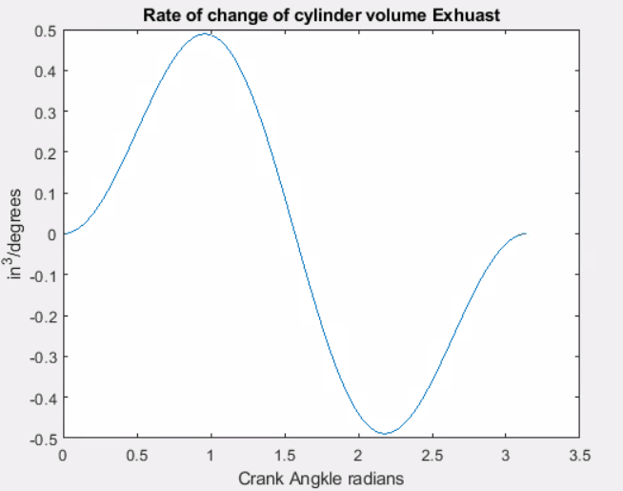

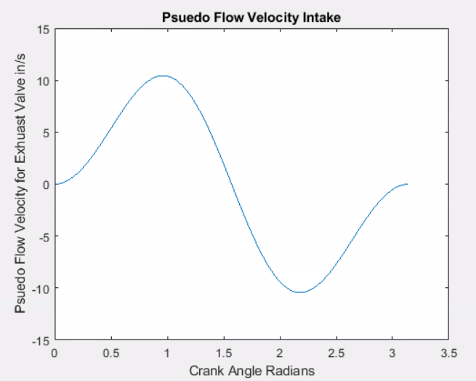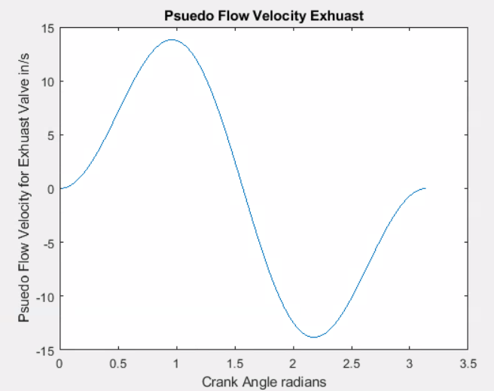

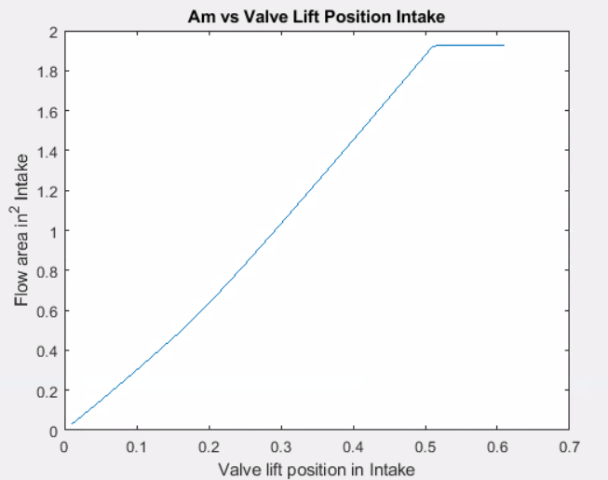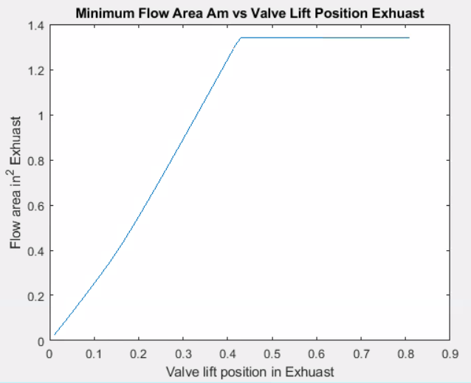

%Engine Characteristics

rc = 10; %compression ratio

BL = .97; %Bore to stroke ratio

Vd = 53.12; %Volumetric displacement in cubic in

B = (Vd \* 4 \* BL / pi) ^ (1/3); %Bore in in

Vc = Vd / (rc - 1); %Clearance volume (in^3) (EQN 2.1)

L = B / BL; %Stroke length (cm)(EQN (in)

a = L / 2; %Crank radius (cm)(EQN 2.3)

l = 1.75 \* L; %connecting rod length (in)

theta1 = 0; %crank angle (initialized value in radians)

s2 = a \* cos(theta1) + (l^2 - a^2 \* sin(theta1)^2)^0.5; %distance parameter (EQN2.5)

Vt0 = Vc + (pi / 4) \* B^2 \* (l + a - s2); %Volume in terms of crank angle (cc) (EQN 2.4)

%N = 5000; %Rotational speed (RPM)

%Spa = 2 \* L \* N / 60; %Mean piston speed (cm/s)(Eqn 2.9)

Lvmaxi = .61; %Valve lift in in

%Intake Valve Parameters

Dvi = .36\*B; %Valve Diameter

Dsi =.21\*Dvi; %Inlet Valve Diameter

Dpi = 1.1\*Dvi; %Port Diameter

wi = (1.1\*Dvi-Dvi)/2; %Seat Width

Dmi = Dvi-wi; %Mean Seat Diameter

beta = 45\*3.1415/180; %Seat Angle

Lvi1 = wi/(sin(beta)\*cos(beta)); %Lift Threshold 1

Lvi2 = (((Dpi^2-Dsi^2)/(4\*Dmi))^2-wi^2)^.5+wi\*tan(beta); %Lift threshold 2

%Instanteous Flow Area as a function of Lift Value incrimenting from zero

%to Lvmax

k = 0;

for (i = .01:.01:Lvmaxi)

k = k + 1;

if (i < Lvi1)

Ami1(k) = 3.14\*i\*cos(beta)\*(Dvi-2\*wi+i/2\*sin(2\*beta));%minimum area flow rate low lift

elseif (Lvi1 <= i & i <= Lvi2)

Ami2(k - length(Ami1)) = 3.14\*Dmi\*((i-wi\*tan(beta))^2+wi^2)^.5; %minimum area flow rate median lift

else

Ami3(k-(length(Ami2)+length(Ami1))) = 3.14/4\*(Dpi^2-Dsi^2); %high flow area - constant high lift

end

end

Ami = [Ami1 Ami2 Ami3];

figure

plot(.01:.01:Lvmaxi, Ami)

title('Am vs Valve Lift Position Intake')

xlabel('Valve lift position in Intake')

ylabel('Flow area in^2 Intake')

for k = 1:180

thetadi(k) =(k)\* pi / 180; %theta in radians

dsdthetai(k) = -a\*sin(thetadi(k))\*-(l^2-a^2\*sin(thetadi(k))^2)^(-.5)\*a^2\*sin(thetadi(k))\*cos(thetadi(k)); %derivitiave of s as a function of tehta

Vpsi(k) = 3.14\*B^2/(4\*Ami2(5))\* dsdthetai(k); %EQN 6.10

end

figure

plot(thetadi,Vpsi)

title('Psuedo Flow Velocity Intake')

xlabel('Crank Angle Degrees Radians')

ylabel('Psuedo Flow Velocity for Exhuast Valve in/s')

figure

plot(thetadi,dsdthetai)

title('Rate of change of cylinder volume Intake')

xlabel('Crank Angkle Degrees Radians')

ylabel('in^3/degrees')

%Exhuast Valve Parameters

Lvmaxe = .81 %Exhuast Valve Lift in

Dve = .3\*B; %Valve Diameter in

Dse =.21\*Dve; %Inlet Valve Diameter in

Dpe = 1.1\*Dve; %Port Diameter in

we = (1.1\*Dve-Dve)/2; %Seat Width in

Dme = Dve-we; %Mean Seat Diameter in

beta = 45\*3.1415/180; %Seat Angle

Lve1 = we/(sin(beta)\*cos(beta)); %Lift Threshold 1

Lve2 = (((Dpe^2-Dse^2)/(4\*Dme))^2-we^2)^.5+we\*tan(beta); %Lift threshold 2

%Instanteous Flow Area as a function of Lift Value incrimenting from zero

%to Lvmax

k = 0;

for (i = .01:.01:Lvmaxe)

k = k + 1;

if (i < Lve1)

Ame1(k) = 3.14\*i\*cos(beta)\*(Dve-2\*we+i/2\*sin(2\*beta));%minimum area flow rate low lift

elseif (Lve1 <= i & i <= Lve2)

Ame2(k - length(Ame1)) = 3.14\*Dme\*((i-we\*tan(beta))^2+we^2)^.5; %minimum area flow rate median lift

else

Ame3(k-(length(Ame2)+length(Ame1))) = 3.14/4\*(Dpe^2-Dse^2); %high flow area - constant high lift

end

end

Ame = [Ame1 Ame2 Ame3];

figure

plot(.01:.01:Lvmaxe, Ame)

title('Minimum Flow Area Am vs Valve Lift Position Exhuast')

xlabel('Valve lift position in Exhuast')

ylabel('Flow area in^2 Exhuast')

%Effect of valve geometry and timing on airflow by the pseudo flow

%velocity for each valve

%sx = a \* cos(x) + (l^2 - a^2 \* sin(x)^2)^0.5;

for k = 1:180

thetade(k) =(k)\* pi / 180; %theta in radians

dsdthetae(k) = -a\*sin(thetade(k))\*-(l^2-a^2\*sin(thetade(k))^2)^(-.5)\*a^2\*sin(thetade(k))\*cos(thetade(k)); %derivitiave of s as a function of tehta

Vpse(k) = 3.14\*B^2/(4\*Ame2(5))\* dsdthetae(k); %EQN 6.10

end

figure

plot(thetade,Vpse)

title('Psuedo Flow Velocity Exhuast')

xlabel('Crank Angle Degrees')

ylabel('Psuedo Flow Velocity for Exhuast Valve in/s')

figure

plot(thetade,dsdthetae)

title('Rate of change of cylinder volume Intake')

xlabel('Crank Angkle Degrees Radians')

ylabel('in^3/degrees')